**Making Mobility Better with Mantle**

Mantle is a product of [BitDAO](https://coinmarketcap.com/alexandria/article/what-is-bitdao-bit), a [decentralized autonomous organization](https://coinmarketcap.com/alexandria/glossary/decentralized-autonomous-organizations-dao) (DAO) launched by [centralized exchange](https://coinmarketcap.com/alexandria/glossary/centralized-exchange-cex), ByBit, to support and empower builders in the crypto space

Mante allows **hyper scalability** of the Ethereum network, leveraging roll-up technology and a decentralized data availability layer to increase efficiency and performance in the mobility ecosystem, all while reducing fees and latency. Building with an Ethereum roll-up technology also means that Mantle offers unparalleled security, all packaged in a familiar EVM environment for users and developers.

**Impact** of Using Mantle in Mobility industry:

A greater and more seamless flow of information within mobility infrastructure encompasses and leverages digital progress and can transform the way mobility services are delivered and compensated:

* Mobility ecosystem **proactive, accessible and authentic** using Mantle.
* Community Coordination with the help of Mantle and computer aided detection will help in **early prediction of incidents**. Scaling using Mantle enables on-chain collaboration at a lower transaction costs.

**Mantle’s Features for better Mobility**

**Incident Data Availability**: Mantle’s Modular Data Availability is able to increase transaction throughput beyond incumbent L2 solutions, reducing processing requirements and increasing decentralization without compromising on security features.

**Multi-Party Computation (MPC)**: Mantle greatly reduces the trust risk of L2 execution results with MPC. With Threshold Signature Scheme (TSS) technology, the correctness of off-chain transaction execution results is vastly improved, lowering the challenge period for withdrawals.

**Decentralized Sequencer**: Mantle utilizes a Decentralized Sequencer to facilitate secure and trustless block production, negating the issue of a single point of failure and censorship on the network.

**Connected Vehicles for Efficiency and Sustainability using Mantle**: Mantle enables **Connected Vehicles for Efficiency and Sustainability.** Users can issue, manage and transfer credits of ratings earned for vehicle owners and their respective vehicles via pollution checks, green fuel adoption in vehicles on Mantle Blockchain. Workflow and platform features that can be implemented with SocialCalc (EtherCalc) and Mantle blockchain for better mobility are:

- User creation procedure; User identification with NFC tags;

- Create credits of ratings earned via pollution checks, green fuel assets;

- Issue green credits for vehicles via pollution checks;

- List green credits per vehicle; Handle multiple vehicles.

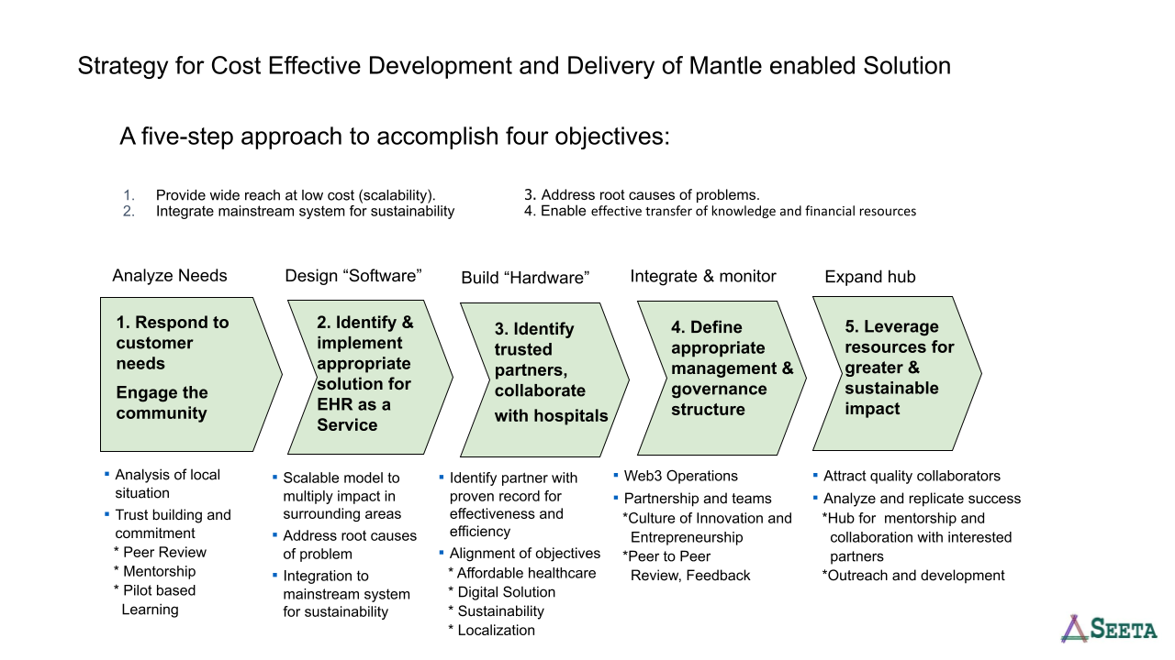

**Opportunity for Open Source Developers to collaborate in Mantle eco-system**

Developer tooling in Mantle can be extended and adapted to a variety of key use-cases in the mobility ecosystem.

We worked on one such module for sustainability: **Alarm Viewer.**

The alarm viewer with Mantle Blockchain can be used in case a vehicles' quarterly pollution check is due or has not been completed one week before the penalty set by the government authorities. This alarm viewer can be further extended by the developers to build community tools, analytics and visualization tooling by adding features like pollution check performance ratings and raising alarms and notifications when the registry of a vehicle to operate in a region expires (example: 15 years for petrol vehicles and 10 years for diesel vehicles in Delhi).

The alarm viewer application can also be extended for the use case where the pollution testing equipment does not give optimal results, which is very much true when a vehicle has traveled more than 45,000 kms.